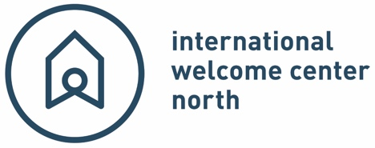
PRESS RELEASE

WITH LAUNCH OF NEW WEBSITE, IWCN, CONNECT INTERNATIONAL AND CITY CENTRAL MERGER COMPLETE
Groningen, 26 July 2023 – After successfully merging three northern organisations for international residents – International Welcome Center North, City Central, and Connect International – the new and improved IWCN is announcing the launch of its new website.
The website boasts improved navigation through IWCN’s vast wealth of practical knowledge on all matters related to getting settled in the northern Netherlands. In the new events section, users have the option to filter by event location (Groningen, Drenthe, Friesland or online) and type (wellness, language support, social). IWCN is also introducing a members only section, where members can keep track of the past events they have attended.
The goal of the new site is to better serve the social and professional needs of international students, highly skilled migrants and their families, and northern companies that hire foreign talent in Groningen, Drenthe and Friesland.
The website launch also symbolizes the formal coming together of three great northern organisations catering to the international community. Over the course of 2022, IWCN went through the demanding yet rewarding process of incorporating two local socially-focused projects – City Central and Connect International – into their business.
IWCN was founded in 2014, and works with local municipalities and employers across the north to provide formalities for employees and their families moving to the region from abroad.
Connect began 25 years ago, in 1998, as a place for newcomers to the north to connect with one another and start building their own social circle in their new home.
City Central started in 2017 with the goal of bringing international students and young professionals in the city of Groningen together with the long-term local population.
The launch of the site, designed by Junction creative + digital agency in Leeuwarden, marks the symbolic relaunch of the new IWCN.
Michiel Kastelein, IWCN's business manager, says, "After eight and a half years, IWCN has become an indispensable decisive factor for international and international companies in the North. This year, we've joined forces with City Central and Connect International, and along with that comes the introduction of stronger services online with a new website that provides even further improved support for all the internationals, companies and partners that we work on behalf of. What does the future hold? We're already there!"
Karen Prowse, Operations Manager: “”
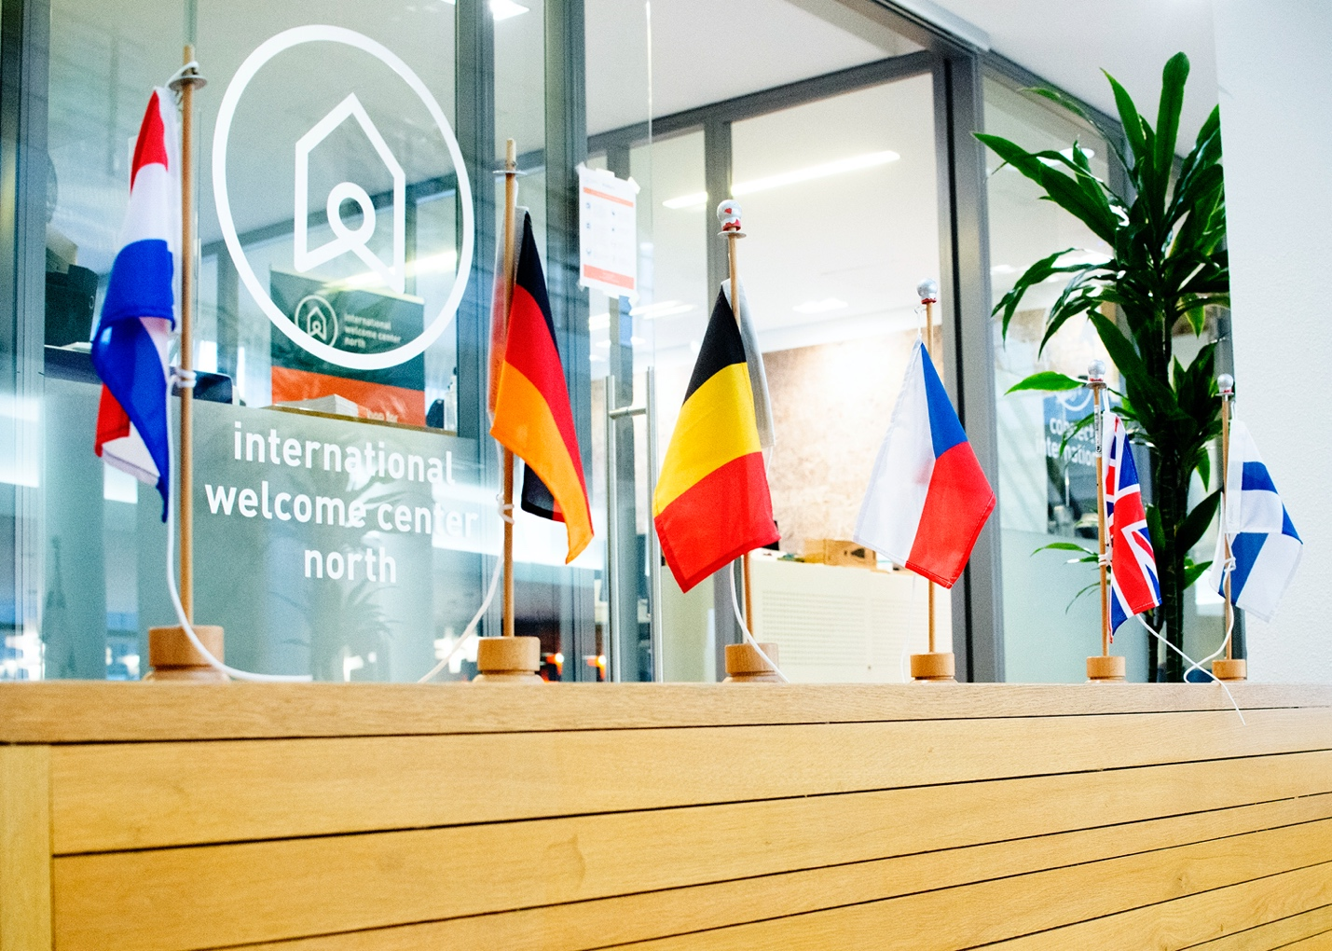
© IWCN/ Traci White
-------END OF PRESS RELEASE ------
About IWCN – The International Welcome Center North (IWCN) is a one-stop shop for international people living in, and companies located in, Groningen, Friesland and Drenthe. We offer government formalities (residence permits and municipal registration), information (practical information and referrals to reliable service providers) and social activities (a chance to start building a social and/or business network during activities and events). We also provide onboarding guidance to companies with international employees.
Attached images are for (one-off) publication in print or online. Use the image quoting the following credit line: ©IWCN / name photographer.
Contact details
___________, Communications team coordinator
Telephone: +31 (0)50 367 71 97
Email: communication@iwcn.nl
Address: Gedempte Zuiderdiep 98
9711 HL Groningen
Additional information is available at our website: www.iwcn.nl
Social Media
Facebook
Instagram
LinkedIn
Hashtags
#iwcn #embracethenorth #wearethenorth

